Group: Mercury In Fillings Are Dangerous

By Holly Love
The Trend Midweek May 21, 2003

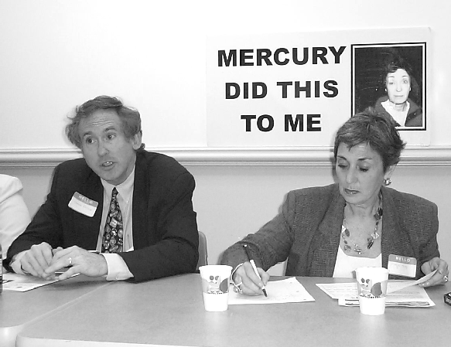
Attorney Charles Brown represents Consumers for Dental Choice, a nonprofit group that is working to stop the use of mercury in dental fillings. Right, Freya Koss is the national director of the organization. Above her is a picture of herself, showing signs of mercury poisoning that she said she got from dental fillings.
Photo by Holly Love

In 1998, Freya Koss, of Wynnewood, was struck with double vision. Weeks later she developed drooping eyelids and was diagnosed with multiple sclerosis and other auto-immune diseases. Her urine tests revealed high levels of mercury, which Koss says caused her illnesses. She says the mercury came from the amalgam fillings in her teeth.

Koss is now the national director of development for Consumers for Dental Choice, a nonprofit organization working to abolish the use of mercury amalgam dental fillings. On April 30 at the Bala Cynwyd Library, she spoke at a forum on the fillings’ health hazards. “Mercury is the second most toxic substance after plutonium. So many suffer, and they don’t know it’s mercury poisoning,” she said.

According to forum panelist Dr. Frederick Burton, illnesses scientifically linked to silver-mercury amalgam fillings include paralysis, diabetic symptoms, Parkinson’s and Alzheimer’s disease, autism, chronic fatigue syndrome, fibromyalgia, and glandular, digestive, psychological, and infertility problems. “One 19-year-old patient I visited had 20 amalgam fillings, and was so debilitated she was being taken to a home for the disabled. The family couldn’t afford to have the fillings removed,” Burton said.

Attorney Charles Brown represents Consumers for Dental Choice in their legislative efforts. “This is about consumer deception,” he told the dozens of forum attendees. “Our cause is up against an extremely powerful special interest group — the American Dental Association (ADA). For financial reasons, they keep endorsing the use of mercury in dentistry. They’re afraid of people finding out how corrupt they are.”

Despite the risk of defying the ADA, some dentists speak out against amalgam. Two on the forum panel were Drs. Vincent DiLorenzo and Andrea Brockman, DDS, both of Cheltenham. “The state board threatened to take our licenses away even though we can prove all this,” DiLorenzo claims. “Mercury is a bad puppy. Everyone should direct their dentists to the Web site www.toxicteeth.org.”
Brockman added, “In dental school, you’re dismissed if you ask about mercury. You’re told that it’s locked into fillings and can’t hurt you. Yet I drilled amalgam fillings without masks or gloves in the pre-AIDS era, and I suffered adverse symptoms. I also had three pregnancies then, so I called the ADA to ask about dangers to my fetuses. They said ‘We’ll get back to you.’ I’m still waiting.”

Koss later told The Trend Midweek that Dr. Kathryn Chilcote, a music professor at West Chester University in West Chester, was one of the panelists. Chilcote, according to Koss, was a victim of mercury poisoning from dental fillings, in which she allegedly suffered from fibromyalgia, skin conditions, brain fog and a diagnosis of multiple sclerosis. Since having her fillings removed she is slowly recovering and regaining her health, Koss said. Fibromyalgia is when there is muscle, tendon and other soft tissue pain.

Some dentists support the ADA’s position that mercury is safe. Broomall dentist Timothy Brosnan, says mercury can’t escape from an amalgam filling in the mouth. “The FDA approves the fillings, and they wouldn’t if they weren’t safe,” he said. “Silver fillings have great benefits over resin fillings. They last longer, up to 40 years, and cost less. It’s also easier to get good contact between teeth and amalgam fillings, which helps prevent the periodontal disease that can lead to tooth loss.”

One of Brockman’s remarks at the forum addressed that issue. “What’s more important?” she asked. “The life of your tooth, or your life?”

DiLorenzo said he believes it will help clear up the controversy to establish a database to further examine the relationships between illnesses diagnosed in those with amalgam fillings. “We need to track mercury’s presence in those with breast cancer, with neurological problems, with every disease out there, DiLorenzo said. “We also need to better educate not only the public, but also doctors. They’re not taught enough about the mouth. And dentists aren’t taught enough about the rest of the body.”

Some in the audience expressed concern over the great expense in having amalgam fillings replaced. In response, forum attendee Mark Matthews, of Oxford Valley, summarized the overwhelming consensus at the forum. “I think the better question is,” he said, “how much does it cost you to leave those fillings in?”

